How to Run UT Oil Reporting Process

Prerequisites to running the process:

1. Oil sales for month being reported has been ran through revenue distribution.
2. Oil skim and special pricing have been updated and ran through revenue distribution.
3. UT lands master data is updated on Quorum screen

**Note process can only be ran once per reporting date. Amendment cannot currently be handled via system. If process is executed for already finalized month the error below will be received.

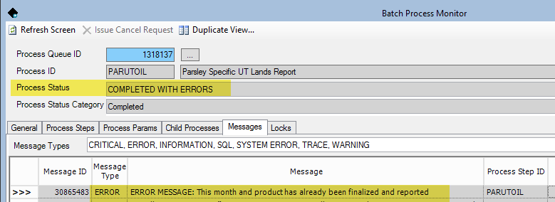

**Step 1:**

Update code table “UT_OIL_PROD” with all the volumes for the wells with UT lands ownership.

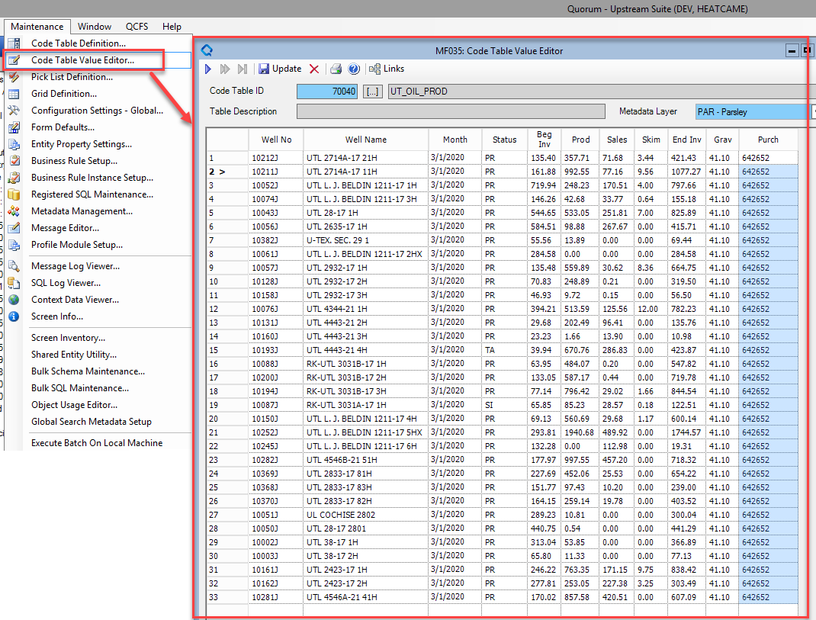

**Step 2:**

Run the process “Parsley Specific UT Lands Report” in QRA. Will need to input month being reported.

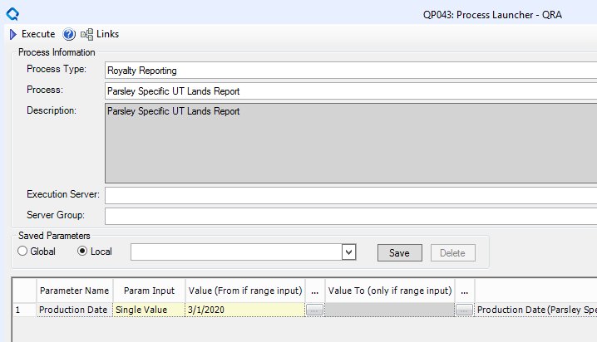

**Step 3:**

Update the parameters and refresh the UT Lands Oil reporting workbook. There are two tabs. The “Report tab” is the format of the report submitted to the UT lands office. The “Property Tie Out” tab, is a comparison of the report numbers calculated to the numbers distributed in Quorum (at the property level).

Verify the numbers agree to what was expected. Manual adjustments might need to be made before report is submitted.

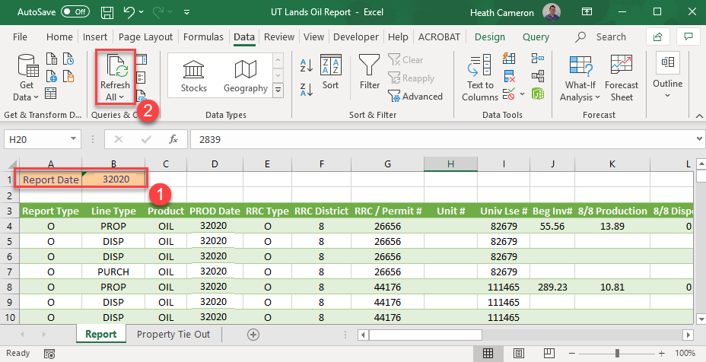

**Step 4:**

In addition to creating the report, the process also created a manual check to record the payments with journal entries.

Go to screen CW025. The created check should have the check number format UT-MMYYYY-OIL. Double click on the check line to bring up the check detail screen CW026.

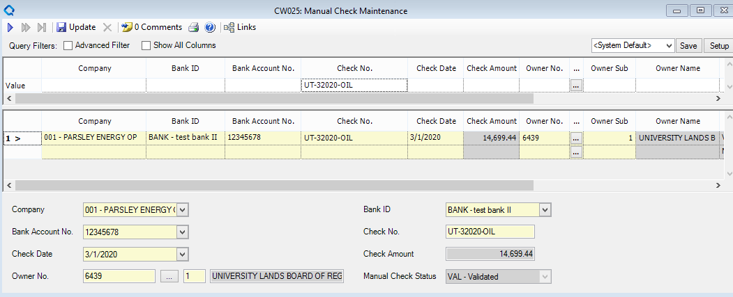

Make any changes to the check detail to make it match manual changes done to the report. The payment should exactly make the check amount.

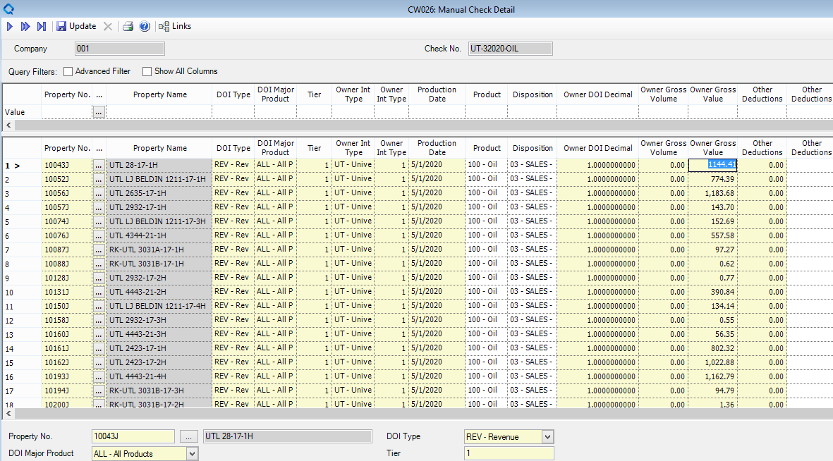

**Step 5 (can be skipped if no manual changes were made to the check):**

Validate the check.

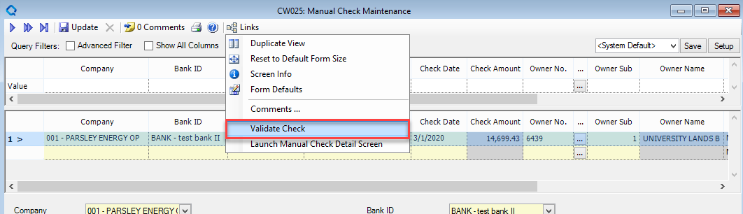

**Step 6:**

Approve the check on screen CW030.

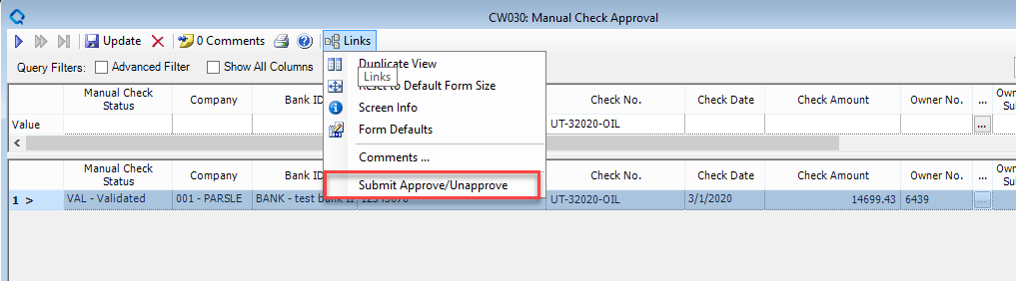

**Step 7 (final step):**

Issue the check via the process below. This will stage the JEs and populate the check register.

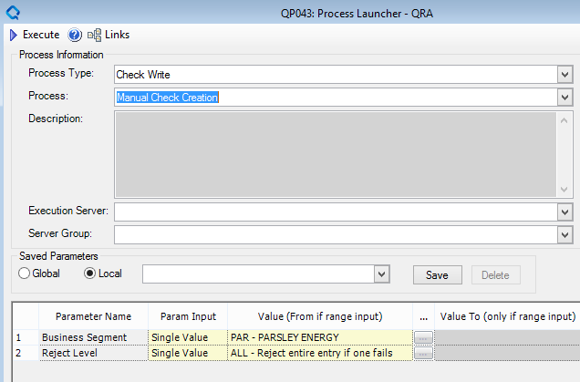

Journal entries staged that will need to be posted.

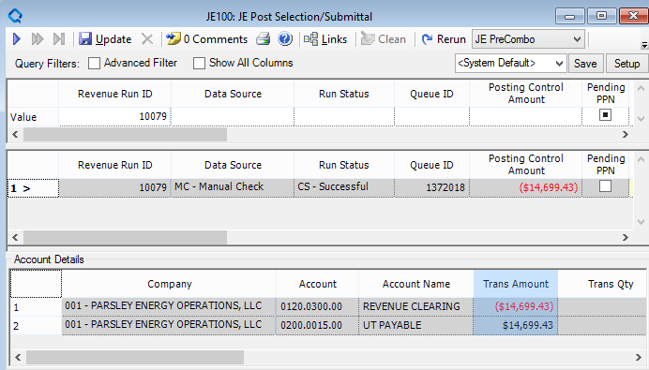

Check in CW005

